|  |  |
| --- | --- |
| Date | 08 November 2023 |
| Team ID | 9FCEEE4EFB15B1C90EB4811A3F79BD60 |
| Project Name | Content Marketing Plan template Based on Hubspot |

1. **Low Online Visibility**: The brand is struggling to gain online visibility, limiting its reach to potential customers in the crowded digital fashion space.
2. **Customer Engagement**: The brand is facing difficulties in engaging customers effectively and building long-term loyalty.
3. **Inventory Management**: Inefficient inventory management is causing financial losses through overstocking and understocking issues.
4. **New Product Launch**: Launching new collections is failing to generate excitement or demand among customers.
5. **Brand Identity**: The brand lacks a clear and consistent identity in the market, making it challenging to stand out.

**Empathize & Discover**

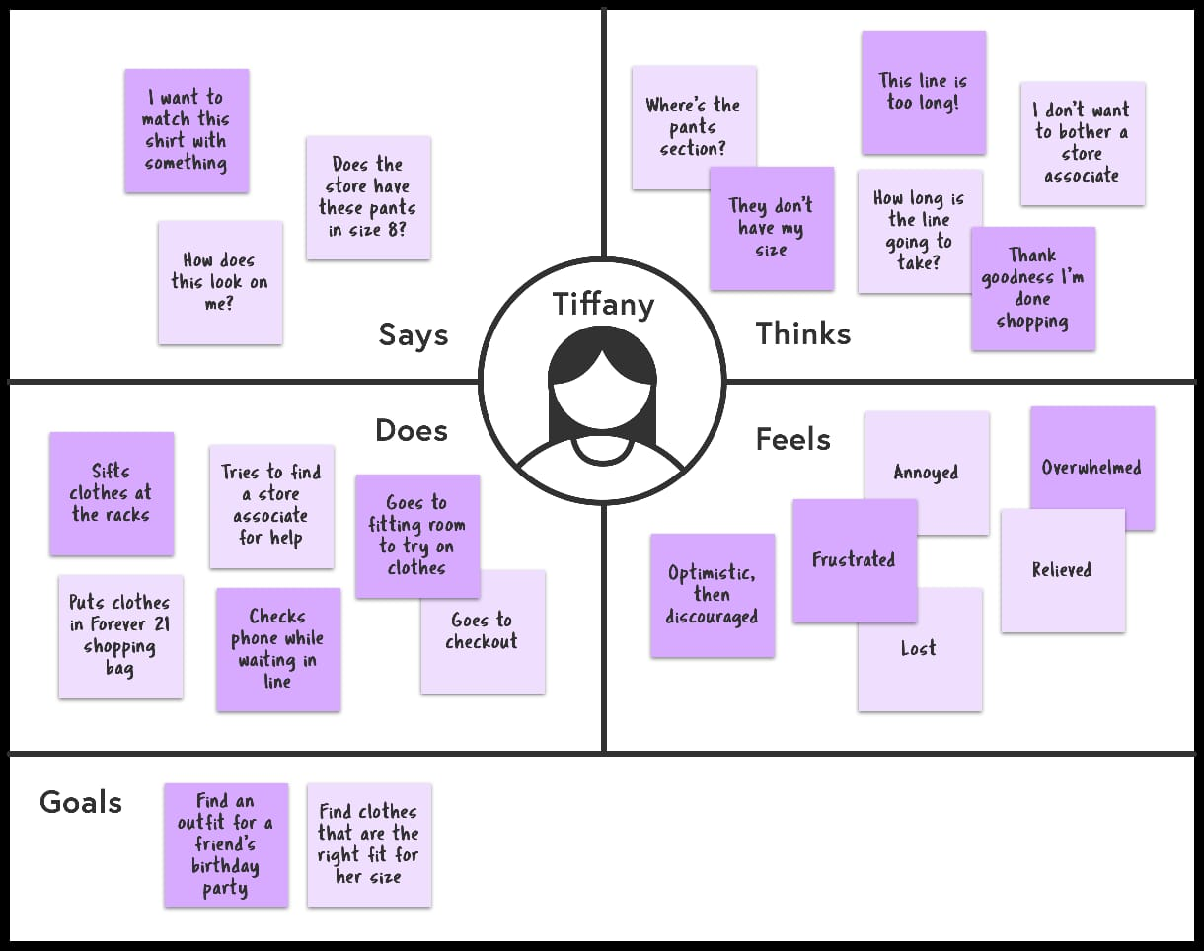

**Brainstrom & Prioritize Idea**

|  |  |  |
| --- | --- | --- |
| **S.no** | **Idea** | **Description** |
| **1** | **Content Themes:** | "Fusion Fashion Fridays": Weekly blog posts or social media content that showcases how to blend traditional and modern elements in fashion.  "Behind the Seams": A video series that takes viewers behind the scenes of the brand's design and production processes |
| **2** | **Interactive Content** | Interactive quizzes or polls on social media to help customers discover their unique style blend.  Virtual try-on tools or apps to allow customers to visualize how different outfits would look on them. |
| **3** | **Customer stories** | "Akshaya Ambassadors": Feature stories of customers who have successfully blended Akshaya Fashions into their daily lives.  "Transformation Tuesdays": Share before-and-after photos of customers embracing the brand's clothing. |
| **4** | **Educational Content** | How-to guides on styling traditional pieces with modern accessories.  Sustainable fashion tips and resources, showcasing the brand's eco-friendly efforts. |
| **5** | **Collaborations** | Collaborate with fashion influencers or cultural experts for webinars or podcasts on traditional fashion.  Partner with other brands to create limited-edition fusion collections. |
| **6** | **User generated Content** | Encourage customers to share their Akshaya Fashions outfits with a unique hashtag for a chance to be featured on the brand's social media. |
| **7** | **Email Marketing Campaigns** | Send out a monthly newsletter with fashion tips, style inspiration, and exclusive discounts.  Abandoned cart recovery emails with personalized recommendations based on the customer's browsing history. |
| **8** | **Sustainability Initiatives** | Highlight the brand's eco-friendly practices through blog posts and social media updates.  Share stories of artisans and craftsmen involved in the brand's production process. |
| **9** | **Holiday & Seasonal Campaigns** | Special collections for cultural celebrations and festivals.  Seasonal wardrobe essentials with a fusion twist. |
| **10** | **Virtual Events** | Host virtual fashion shows or product launches.  Interactive live Q&A sessions with designers or stylists. |
| **11** | **Customer Feedback** | Regularly gather feedback through surveys or social media polls to adapt and improve your products and services. |
| **12** | **Competitions & Giveaways** | Run social media contests with prizes for the most creative fusion outfits.  Host giveaways for loyal customers who share their Akshaya Fashions stories. |